Open Price / Open Weight Barcodes

This document describes how to set up open price and open weight barcodes. The set up for both follow the same rules except for an additional tick box that needs to be ticked for open weight products.

Typically open price barcodes are 13 digits in length but touch is flexible and can read barcodes shorter than 13 digits and can also read 14 digit codes. Open price barcodes follow a set of rules and the barcodes are made up of several parts that need to be followed.

Open Price Barcodes

Example 1 (Price length 5 digits + 2nd check digit enabled)

The screen below is where the open price barcode settings are configured.

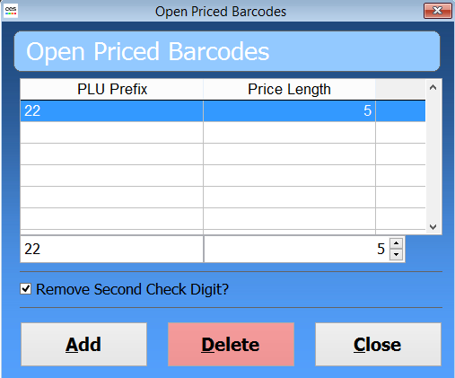

13 digit barcode = 2212349001509 and with the settings in the screen shot above there are 5 parts to this barcode.
PREFIX: SECOND PART OF PLU CODE: 2nd CHECK DIGIT: PRICE: CHECK DIGIT:
22 1234 9 00150 9

The first 2 parts make up the PLU code required for open price items. This example is for a 13 digit open price barcode with 2 check digits and the price length of 5 digits. So the PLU code for the item in Touch needs to be a 6 digit code 221234

The price is set to 5 digits and both check digits are being used so that accounts for the other 7 digits making up the 13 digit barcode. When touch reads in the code it knows that digits 8-12 are the 5 digits that hold the price so 00150 would be sold at £1.50.

Note: The last 7 digits in this example are not populated in Touch, this is an example of a barcode with a £1.50 open price using the above settings.
Example product setup below

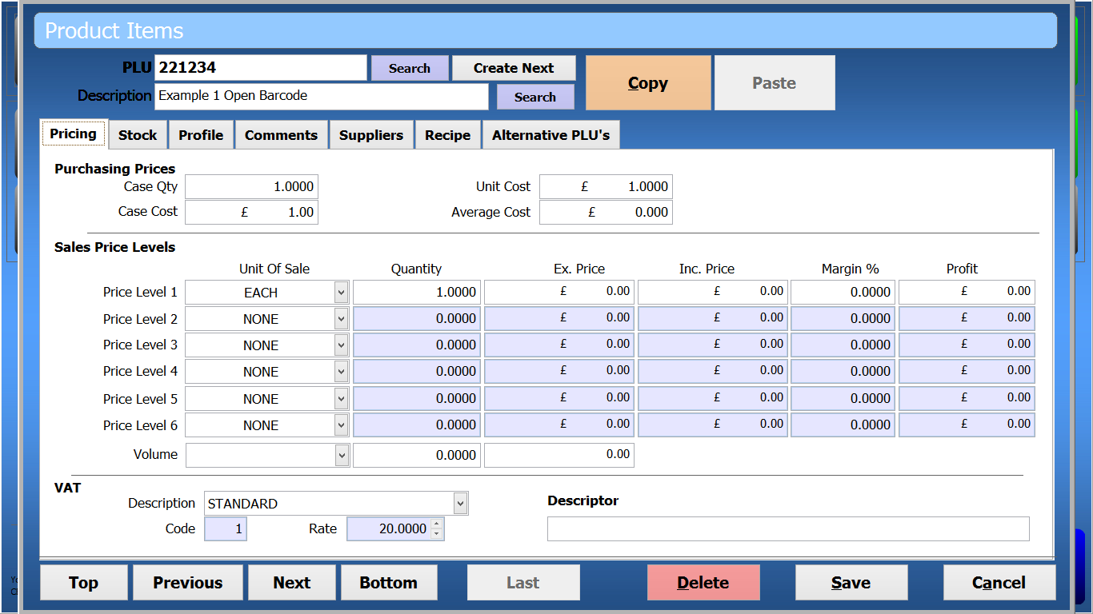

Example sales grid when entering the example barcode 2212349001509. For testing the code can be entered manually.

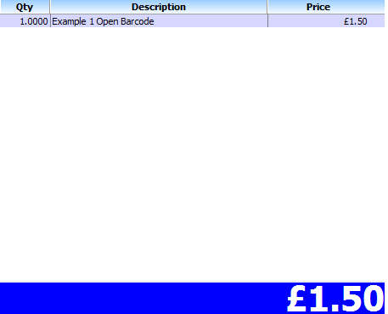

Example 2 (Price length 4 digits + 2nd check digit enabled)

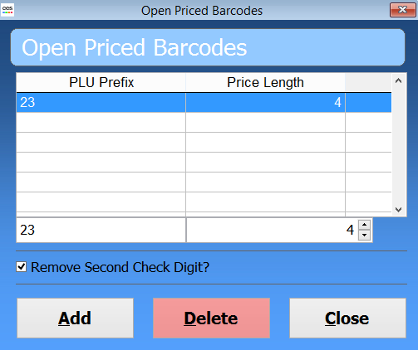

13 digit barcode = 2312345902759 and with the settings in the screen shot above there are 5 parts to this barcode.

PREFIX: SECOND PART OF PLU CODE: 2nd CHECK DIGIT: PRICE: CHECK DIGIT:
23 12345 9 0275 9

This example is for a 13 digit open price barcode with 2 check digits and the price length of 4 digits. So the PLU code for the item in Touch needs to be a 7 digit code 2312345

The price is set to 4 digits and both check digits are being used so that accounts for the other 6 digits making up the 13 digit barcode. When touch reads in the code it knows that digits 9-12 are the 4 digits that hold the price so 0275 would be sold at £2.75.

Note: The last 6 digits in this example are not populated in Touch, this is an example of a barcode with a £2.75 open price using the above settings.

Example product setup below

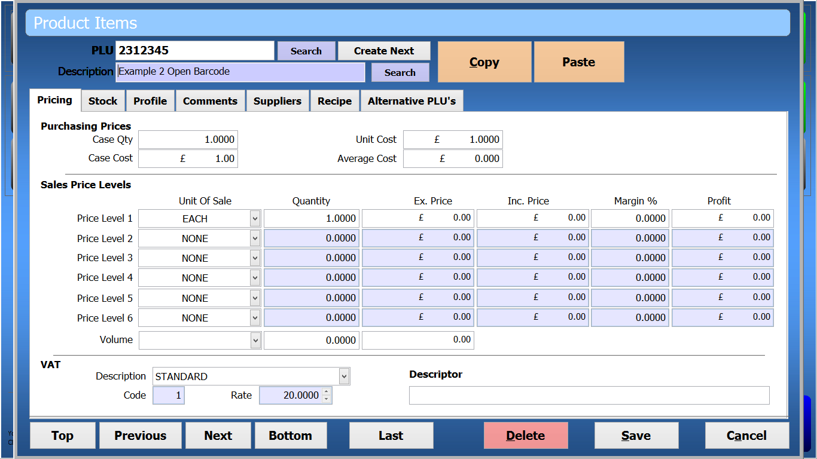

Example sales grid when entering the example barcode 2312345902759

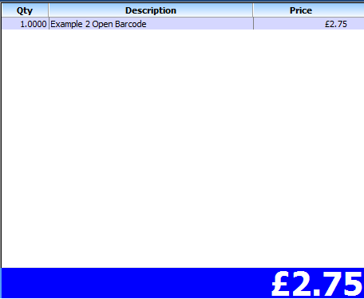

Example 3 (Price length 5 digits + 2nd check digit disabled)

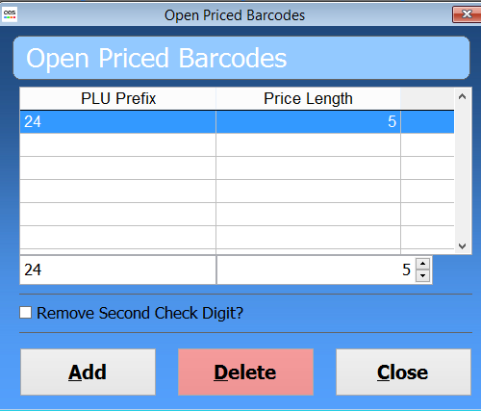

13 digit barcode = 2312345902759 and with the settings in the screen shot above there are 5 parts to this barcode.

PREFIX: SECOND PART OF PLU CODE: PRICE: CHECK DIGIT:
24 12345 00350 9

This example is for a 13 digit open price barcode with 1 check digit and the price length of 5 digits. So the PLU code for the item in Touch needs to be a 7 digit code 2412345

The price is set to 5 digits and only one check digit is being used so that accounts for the other 6 digits making up the 13 digit barcode. When touch reads in the code it knows that digits 8-12 are the 4 digits that hold the price so 00350 would be sold at £3.50.

Note: The last 6 digits in this example are not populated in Touch, this is an example of a barcode with a £3.50 open price using the above settings.

Example product setup below

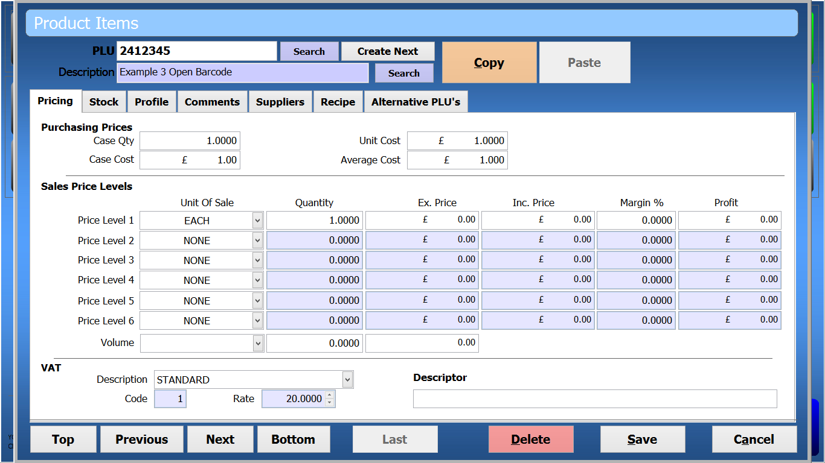

Example sales grid when entering the example barcode 2212349001509

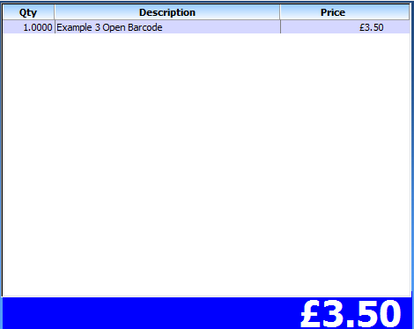

Example 4 (Price length 4 digits + 2nd check digit disabled)

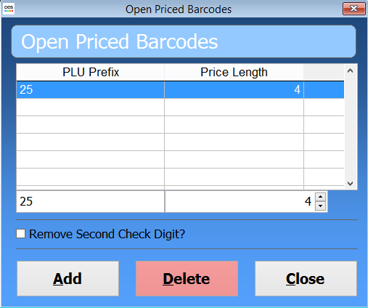

13 digit barcode = 25123456904759 and with the settings in the screen shot above there are 4 parts to this barcode.

PREFIX: SECOND PART OF PLU CODE: PRICE: CHECK DIGIT:
25 123456 0475 9

This example is for a 13 digit open price barcode with 1 check digit and the price length of 4 digits. So the PLU code for the item in Touch needs to be an 8 digit code 25123456

The price is set to 4 digits and only one check digit is being used so that accounts for the other 5 digits making up the 13 digit barcode. When touch reads in the code it knows that digits 9-12 are the 4 digits that hold the price so 0475 would be sold at £4.75.

Note: The last 6 digits in this example are not populated in Touch, this is an example of a barcode with a £4.75 open price using the above settings.

Example Product set up below

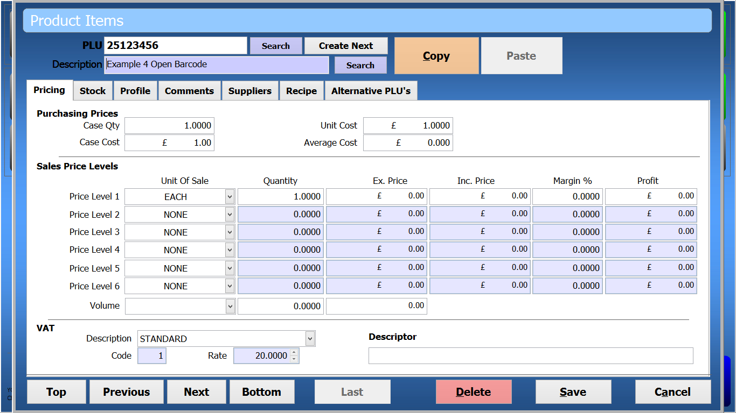

Example sales grid when entering the example barcode 2512345604759

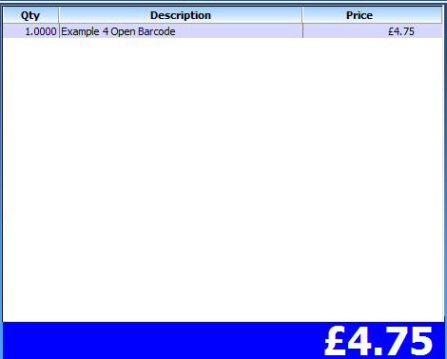

Open Weight Barcodes

Open weight barcodes follow the same set up rules as open price barcodes but require an additional setting against the product as below.

