AFD Postcode
Step 1, Register PCODEX.DLL:

The AFD postcode integration requires 2 dll files ‘postcodex.dll’ and ‘postcode32.dll’ to be copied into the c:\windows\system32 for 32 bit OS or c:\windows\syswow64 for 64 bit OS.
The postcodex.dll file needs to be registered and must be registered before installing the AFD Postcode software
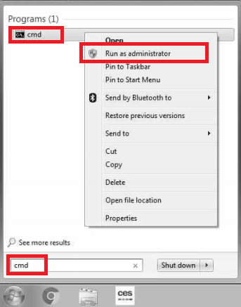
For 32 bit in the command prompt type For 64 bit in the command prompt type
cd\windows\system32 and press enter cd\windows\syswow64 and press Enter
Type regsvr32 postcodex.dll and press Enter Type regsvr32 postcodex.dll and press Enter

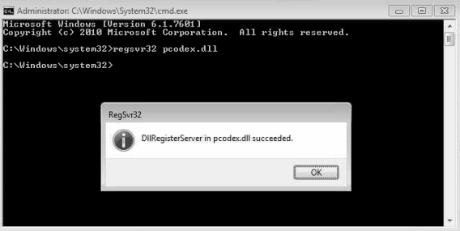

Step 2, Install AFD Postcode Software:

Download the Postcode software from the AFD website, the evaluation version is fine for testing. Once a licence is purchased the valuation version can be licenced and upgraded to the full version.
https://www.afd.co.uk/products/postcode/
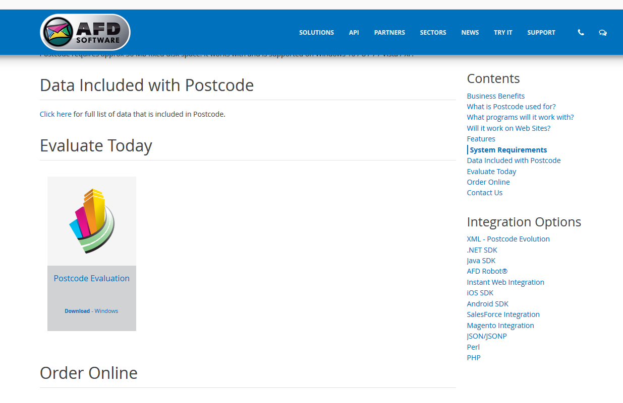
Double click on the installer and run through the wizard.
The evaluation version has a small number of postcodes that can be used for testing as shown below.
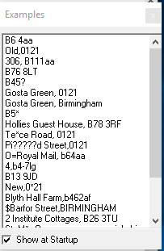
Step 3, Enable Touch Settings

Enable the required AFD systems options in touch.
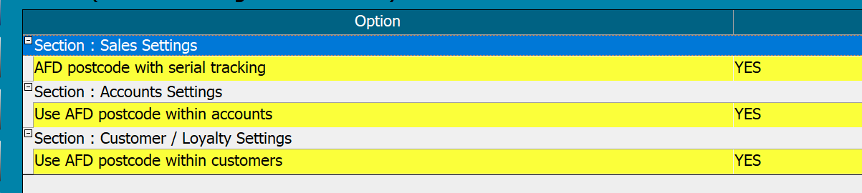
The AFD button will then show in the customer address and serial tracking screens.
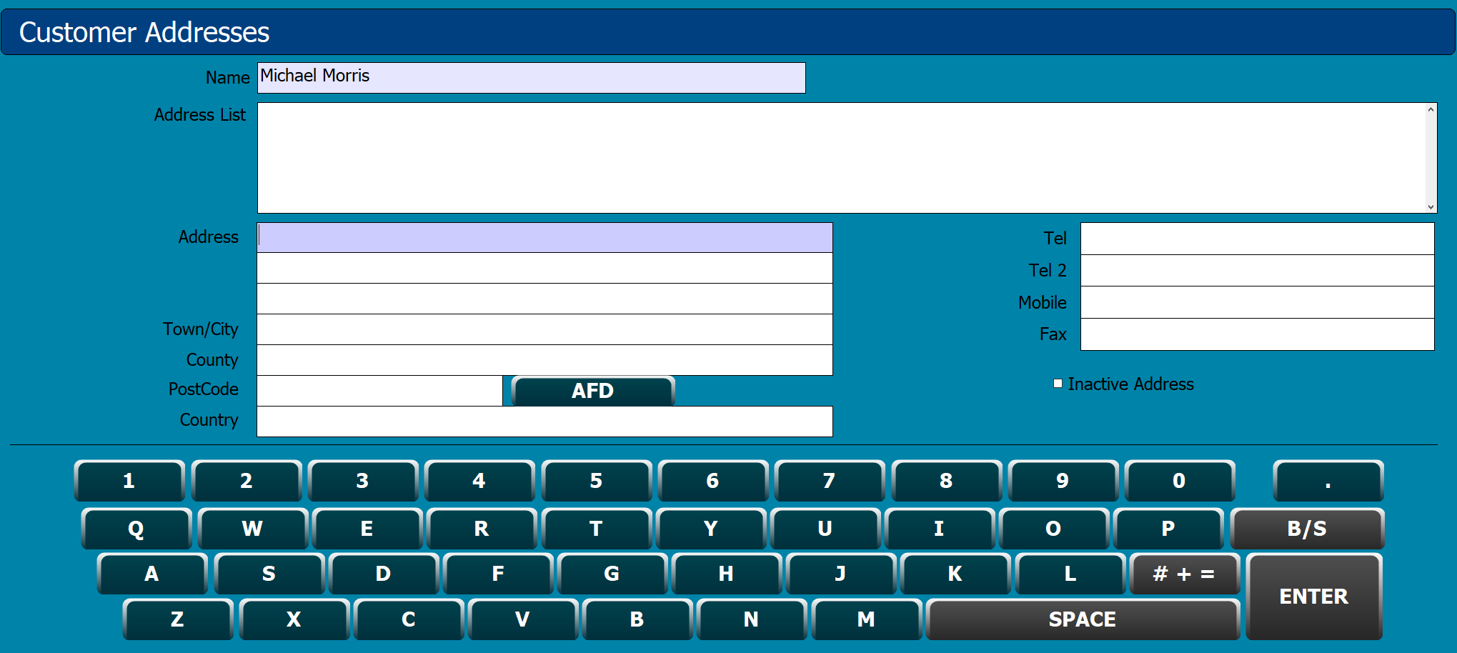
Step 4, Test

- Go into the customer screen and look up or create a customer and go into the maintain address screen.
- Type the test postcode B64AA into the top Postcode box and press search, if working the address below will show.



