Sharing a Touch folder in windows 7 / POS Ready 7
- Open my Computer go to the Touch folder and right click, select Share with then Specific People…
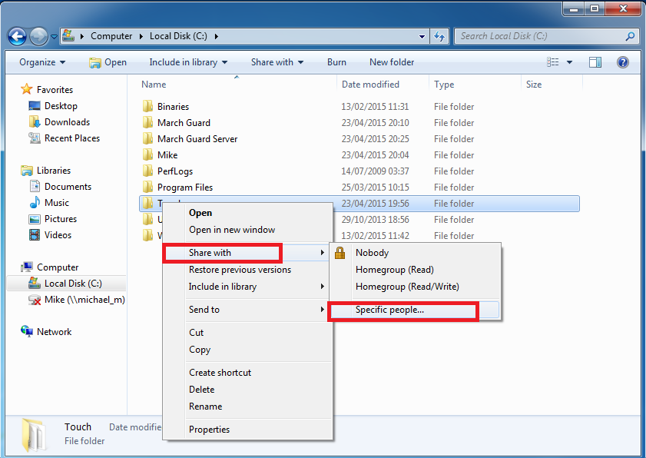
- Type Everyone in the box as below and click Add

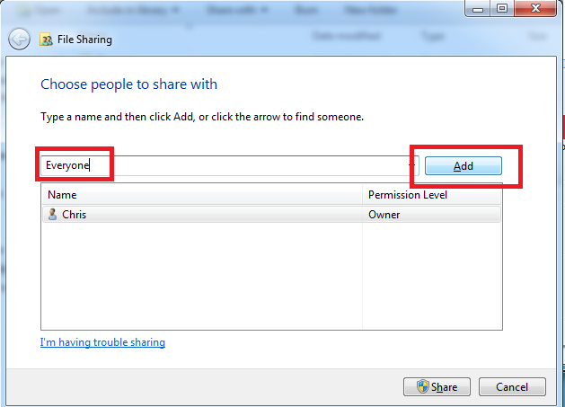

- Move the tick below to Read Write

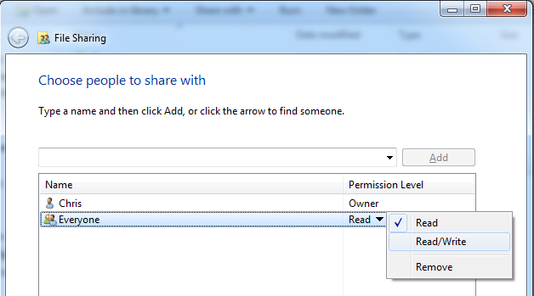

- Ensure the share is set as Read/Write as below then click on the Share button

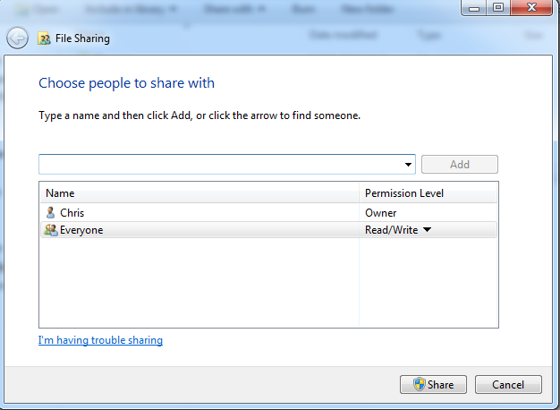

- Once share is pressed it will set it permissions and finish by showing a screen as below.

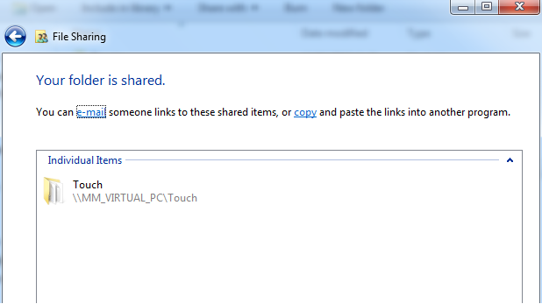

The idea of the network setup in v8.8 was to make things easier and it worked quite well on XP or POS Ready 2009, unfortunately it is not quite so user friendly on Windows 7 or POS Ready 7 due the share permissions that are required.
Whichever method you use to set the paths to link master and slave tills together what you are actually doing is configuring the control.dbf in the root of the touch folder. You can manually edit the control.dbf file on slave tills using dbf navigator to point to the master, this often is the quickest and easiest method.
This really is quite a simple process when you understand what you are doing.
Stage1: You need to share the Touch folder on the master till and give it full read write permissions for everyone as above

Stage2: Go to the slave till and make sure you can see the master till share over the network and connect to the share,
Start/Run \\192.168.1.1\touch\Data (Example IP address)
Stage3: Edit the control.dbf file with dbf navigator to use the master till IP Address if it has a static IP set, if not use the Master till PC name.
Examples With IP \\192.168.1.1\Touch\
Or use the PC name if the master is not on a static IP With name \\Till01\Touch\
There are 4 paths that need to be configured on the slave to map to the master
Example below using the IP Address of 192.168.1.1
1. Server \\192.168.1.1\Touch\Data\ (\ on the end is required very important)
2. Remote \\192.168.1.1\Touch\Remote\
3. Reports \\192.168.1.1\Touch\Reports\
4. Archive \\192.168.1.1\Touch\Archive\

