Sharing a Touch folder in windows 7 / POS Ready 7
- Open my Computer go to the Touch folder and right click, select Share with then Specific People…
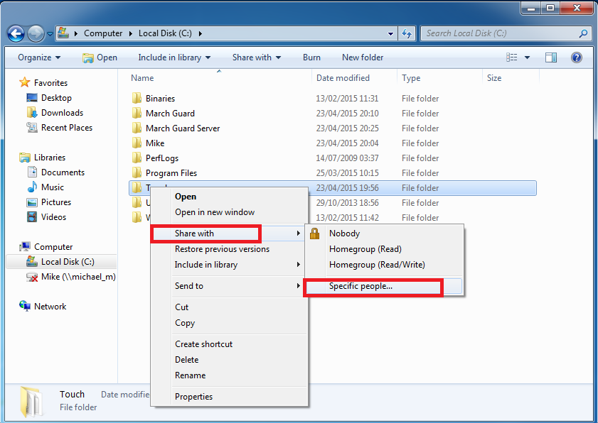
- Type Everyone in the box as below and click Add

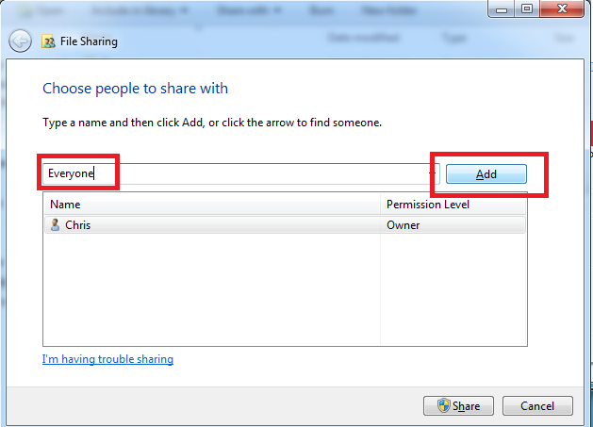

- Move the tick below to Read Write

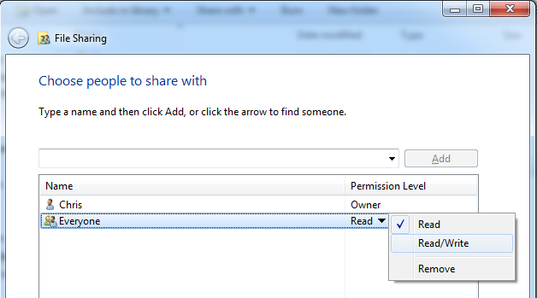

- Ensure the share is set as Read/Write as below then click on the Share button

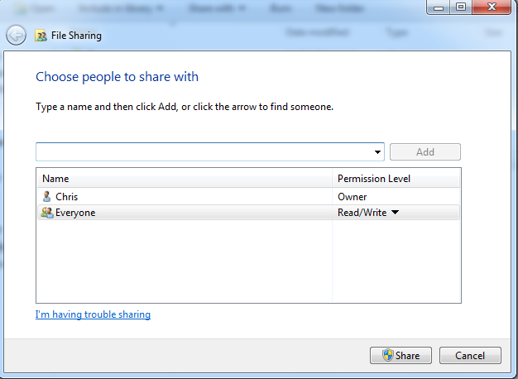

- Once share is pressed it will set it permissions and finish by showing a screen as below.

